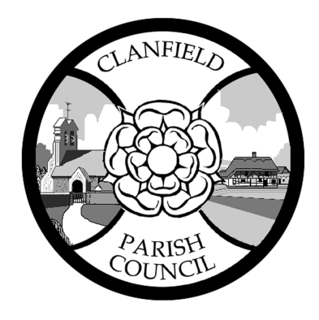
CLANFIELD PARISH COUNCIL
Council Office, The Clanfield Centre, 2 Endal Way, Clanfield PO8 0YF
02392 5571077 / clerk@clanfieldpc.org.uk

FINANCE AND GENERAL PURPOSES COMMITTEE to be held on Tuesday 24 May 2022 at 6.30p.m
at The Council Office, The Clanfield Centre, 2 Endal Way P08 0YF
Entrance Via The Clanfield Centre.
Dear Councillors,

You are hereby summoned to a meeting of Finance and General Purposes Committee for the transaction of business set out below.

Katie Knowles
Clerk
17 May 2022

- Members of the public are welcome to attend.

AGENDA

- TO RECEIVE APOLOGIES FOR ABSENCE.
To receive and approve apologies for absence.

- DECLARATIONS OF INTEREST Councillors are reminded of their responsibility to declare any disclosable pecuniary interest which they may have in any item of business on the agenda no later than when that item is reached. Unless dispensation has been granted, you may not participate in any discussion of, or vote on, or discharge any function related to any matter in which you have a pecuniary interest as defined by regulations made by the Secretary of State under the Localism Act 2011. You must withdraw from the room when the meeting discusses and votes on the matter.

- MINUTES OF THE PREVIOUS MEETING
To approve the minutes of the meeting held 23 March 2021.

- TO ELECT A COMMITTEE VICE CHAIRMAN

- YEAR ENDING 31 MARCH 2022
- To receive a detailed income and expenditure report for the year end.
- To receive and consider the balance sheet for the year end.
- To receive and consider the Annual Return summary for the year end.
- To note the restated asset value for 2020/21, the in-year purchase figure and total asset value for 2021/22.
- To receive a report from the Internal Auditor.

- FINANCIAL STRATEGY

- CCLA INVESTMENT
To consider whether to invest a proportion of the Council’s reserves with the CCLA’s Public Sector Deposit Fund, to maximise income from the Council’s investments.

- UPDATE ON THE COUNCILS BANKING ARRANGEMENTS
- Update on Lloyds Bank
- List of Bank Signatories

- UPDATE ON SITUATION REGARDING FOOTBALL PITCH FEES

- DATES OF NEXT MEETINGS
26 July, 20 September and 22 November 2022 at 6.30pm at the Council Office.

